**The Astrological correspondences of the Tarot cards**

**Introduction**

This section introduces the astrological correspondences of the Tarot cards and is based on the Tarot Wheel, which is shown in Figure 1. It may look a little complicated, but it's not.

What may seem a lot of information to take in for the beginner will actually fit easily into place in the next sections, when the cards themselves are discussed. Read through this chapter, but don't worry if you cant take in all the information just yet.

As you use the Tarot cards for readings, you will find yourself looking back at the wheel more and more in order to get a quick summary of the meanings of the cards. And once the meanings of the all the rings of the Wheel have been understood (and this will take time and usage for the beginner) then a quick glimpse at the correspondences will trigger a deeper understanding of each card.

The Wheel is particularly useful in determining the Tarot cards that corresponds to someone's birth date, and this will be discussed in detail in later sections when Personality cards are introduced.

**The Tarot Wheel**

The rings on the Tarot Wheel will be first introduced and then described in detail after the Wheel itself has been shown.

The following describe the Tarot Wheel shown in Figure 1. The 1st ring is the inner most one, and the 13th ring is the outermost one.

**The first ring** shows whether the astrological sign is **positive** or **negative** in astrological terminology.

**The second ring** shows the symbols of the **astrological** **signs** of the zodiac (same as the ninth ring).

**The third ring** comprises the so called **triplicities** of astrology, the Elements.

**The fourth ring** shows the so called **quadruplicities** of astrology: Mutable, Fixed and Cardinal.

**The fifth ring** shows the **Tarot** **suits** that represent the elements shown in the third ring.

**The sixth ring** shows the **number** of the Tarot card that relates the decans (10° intervals) of the zodiac.

**The seventh ring** shows which **planet** is within the decans.

**The eighth ring** shows the **calendar** **dates** of the 36 zodiacal decans, which are also the dates representing the individual tarot cards and also one of the personal cards of an individual, based on their date of birth.

**The ninth ring** shows the **astrological** **sign** of the cards.

**The tenth ring** shows the **planet** **that** **rules** each of the astrological signs of the zodiac.

**The eleventh ring** shows the **planet** **that** **is** **exalted** in that zodiacal sign, i.e. a planet which has a stronger influence than usual because it shares certain characteristics with the astrological sign.

**The twelfth ring** shows which **Knight, Queen or Prince** (using Crowley terminology) rules which of the minor arcana.

**The thirteenth and outermost ring** shows which quarter of the zodiac is ruled by each of the **Princesses in tandem with the Aces**. These are referred to as Quadrants in astrology.

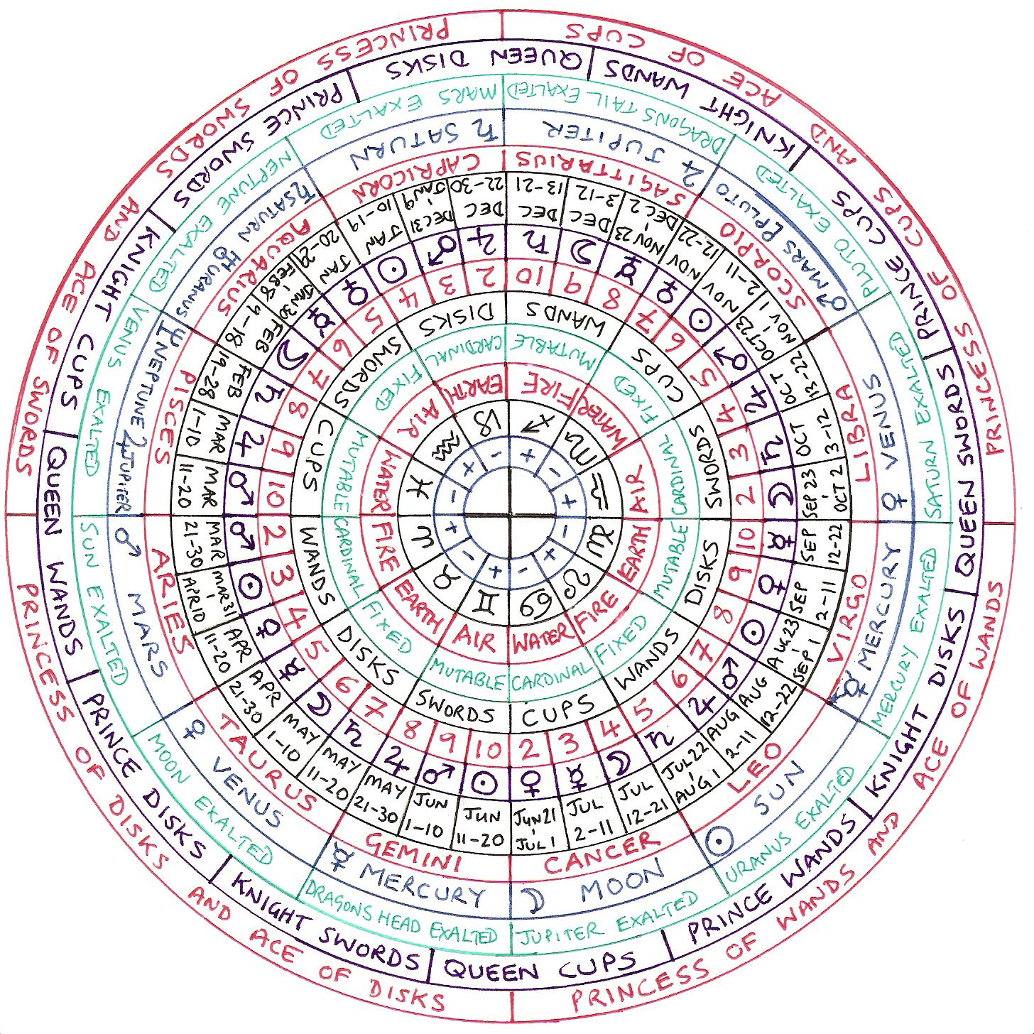Figure 1. The Tarot Wheel

**The 1st ring: Positive and negative signs.**

In Astrology, Positive is used along with terms such as masculine, extrovert and active. Negative is used along with the terms female, introvert and receptive. The terms yin (female) and yang (masculine) could be applied also. In astrological writings positive is usually expressed as self-assertive and negative as self-repressive. Positive and negative terms are applied to entire signs in the zodiac, so Gemini, for example is positive and Cancer is negative. Do not ever confuse positive with 'good' and negative with 'bad', these are entirely inappropriate descriptions.

**The 2nd ring** simply shows the symbols of the astrological signs.

**The 3rd ring: The triplicities**

The triplicities are the four elements. Fire is energetic and assertive. Earth is practical and restrained. Air is communicative and mentally active. Water is emotional and intuitive. The elemental properties of the cards were introduced in Chapter 1, and clearly this ring relates to the 5th ring, which shows the Tarot suits. We learned in Chapter 1 that Fire represents Wands, Water represents Cups, Air represents Swords and Earth represents Disks.

**The 4th ring: The quadruplicities**

In astrology there are 3 quadruplicities: Mutable, Fixed and Cardinal. Mutable signs are variable and adaptable. Fixed signs are intense and steadfast and cardinal signs are enterprising and indicate motion. These are used in conjunction with the elemental signs. Each of the Elements (i.e. the suits, or the triplicities) occurs 3 times in the zodiac wheel and each element is either Mutable, Fixed or Cardinal. The 3 categories (quadruplicities) of the 4 elements (suits or triplicities) gives us the 12 signs of the zodiac.

So for example the cardinal signs show enterprise. Aries (Cardinal Fire) will be energetically and assertively enterprising. Cancer (Cardinal Water) will be emotionally and intuitively enterprising. Libra (Cardinal Air) will be mentally and communicatively enterprising and Capricorn (Cardinal Earth) will be calculating and steadfast and will be enterprising without taking risks. As Cardinal also represents motion, then Aries will be very fast, as Air is already with its own movement. The usually slow Earth will also be somewhat speeded up.

Crowley describes the quadruplicities as follows: “Cardinal represents the first onrush of that element, they burst into their elements ´Here I am´. Fixed signs define and concentrate the element `This is what I am`. Mutable signs are more subtle, they do not express the energy of the cardinal, or the stability of the fixed, but they are not weak, just sensitive and willing to give of themselves. They are flexible and can adapt the element to the adventures of an ever changing universe”.

**The 5th and 6th rings** show the suit and number that comprise the minor arcana, or pip cards. It can be seen that the Twos, Threes and Fours are associated with the cardinal signs, the Fives, Sixes and Sevens with the Fixed signs and the Eights, Nines and Tens with the Mutable signs. Each card represents on decan (10 degree section) of the zodiac.

**The 7th ring: The Planets of the decans.**

Each decan, or each pip card, is governed by a planet. A fuller description the influence of the planets is given in the description of the cards themselves. As a general overview the following descriptors are often used in astrological discussions about the influence of the planets:

**The Sun** – Represents who you are, how you self integrate and how much Sun energy you have. The Sun's energy enhances whatever other energy is already present.

**The Moon** – Governs your emotions, rhythms and instinctive response to life. It also represents the early years of life, your relationship to your mother, and your mood swings and moon cycles.

**Mercury** – Determines how you communicate, but represents communications in general as well as mental ability, expressiveness, nervous reaction and adaptability. Mercury is the messenger of Jupiter, the eternal teenager and is fast and furious. Mercury produces talkers, traders and intellectuals and brings money through work and trade.

**Venus** – Influences how you love, your unity, the quality and intensity of the feelings and affections, your sense of personal values and your ability to form intimate relationships.

**Mars** – Influences how you act, represents activity in general, shows strength and quality of energetic, passionate and emotional expression. The energy is often forceful and practical and has sexual inclinations.

**Jupiter** – Governs how you expand and grow, as well as expansion in general, joy, ability to seize opportunities for expansion through growth, materialism,understanding and luck. Jupiter is the God of gods, the supreme power and is kind, giving and generous, although very naïve. Jupiter brings money through gifts (like Ganesh).

**Saturn** – Influences how you learn and both wisdom and frustration, as it is often through your frustrations that you learn in life. Saturn is formative and gives the ability for self-discipline but also can provide a sense of personal inadequacy and limitation, often through self-consciousness or just getting old. Saturn can be slow, heavy, obstinate and obscure. This planet also relates to structures, including your bone structure.

The planets **Uranus, Neptune and Pluto** revolve every 7, 14 and 21 years, respectively, so they effect whole generations and are often ignored in astrological terms. **Uranus** is associated with breaking free, freedom and originality of expression and unconventional experiences; **Neptune** with spirituality, mystical and religious ideals and peculiar or chaotic development; **Pluto** with death, transformations and explosive endings and beginnings to distinct phases of life developments. Pluto is the brother of Jupiter and rules over Hell.

**The 8th ring** shows the Calendar dates of the individual cards/decans.

**The 9th ring**: Shows the Astrological Signs.

This is a huge subject and only a brief introduction in the form of key words is included here:

**Aries**. Ruled by Mars, Positive, Cardinal Fire.

Self expressive, energetic, undomesticated and assertive. Spontaneous, objective, urgent, impulsive, restless, impatient, frank and direct. Quick thinking and quick witted but not reflective or philosophical. Passionate but not tactful, strong sexual feelings and demands. Can be selfish, argumentative, quick tempered, aggressive and foolhardy. They like to protect themselves. They can suffer from a lack of empathy, ‘Me’ is important to them, they know who they are and are not self-reflective, though equally they do not suffer from self deception.

**Taurus**. Ruled by Venus, Negative, Fixed Earth.

Restrained, domesticated, with boundaries, self-repressive, reliable, passive, intense, practical, steadfast, productive and enduring. Unflinching in attack. Likes comfort, good food, art, beauty and harmony. Mentally stable, methodical, deliberate, constructive but unoriginal and can be boring. Very affectionate, sensual, instinctively aware of the power of their bodies sexually. Possessive, even over-possessive, self-indulgent, self-centred and grasping. They seek security.

**Gemini**. Ruled by Mercury. Positive, Mutable Air.

Communicative, self-expressive, mentally active, interested in the universe around them, adaptable, variable, spontaneous, restless, inquisitive, likes change. Inconsistent, witty, chatty, never dull. Intelligent, light hearted in love, fickle, coolly affectionate, flirtatious, can be superficial, two faced, inconsistent and cunning. They need to adjust to their environment.

**Cancer**. Ruled by the Moon. Negative, Cardinal Water.

Emotional, intuitive, self-repressing, passive and enterprising. Always in touch with their roots, their past and their relationships with their mother. Defensive urge to protect and nourish. Hard outer but soft inner, highly sensitive and easily hurt inside but still hold an impression of external toughness. Resourceful, clannish, patriotic, sympathetic, imaginative, sentimental and moody. Shrewd with a good memory. Artistic, impressionable to psychic influences, romantic, tender, protective and touchy. Can be too moody, prone to self-pity, timid, untidy, unstable and nationalistic.

**Leo**. Ruled by the Sun. Positive, Fixed Fire.

Egotistical, creative, self-expressive, energetic, impressive, authority figure; a natural leader who can inspire others to create. Fixed Fire gives self control but can be dominating and overbearing. Warm hearted, broad minded, good organizer. Self-assured, intellectually inclined and able to look at broad patterns. A powerful and sincere lover. Can be pompous, bombastic, selfish, patronizing and with an urge for power.

**Virgo**. Ruled by Mercury. Negative, Mutable Earth

The only female symbol in the zodiac. Self-repressive, always helping others, passive, restrained, practical, adaptable and variable. Analytical, efficient perfectionist seeking efficiency. Critical, reserved, intelligent, shrewd, discerning, modest, conventional lover. Can be too critical, too modest and a worrier, always looking for compromise they often lose track of who they are. Can be a hypochondriac.

**Libra**. Ruled by Venus. Positive, Cardinal Air.

Self-expressive, loving, communicative, mentally active, harmonious, charming, intelligent, kind, diplomatic and idealistic. Can be lazy and easily influenced by others. Romantic and sentimental, never critical. Can be too easy going. Changeable, can lack confidence. Has a sense of social duty. Likes art and beauty.

**Scorpio**. Ruled by Pluto and Mars. Negative, Fixed Water.

Self-repressive, passive, emotional, intuitive, intense and steadfast. They are always aware of their own mortality and the nature of death. Penetrating attitude, intenseness, urge to identify with one’s source. Intensity of expression, thinking and feeling. Strong will, penetrating eyes, power and passion of conviction. Subtle, secretive and purposeful can be brutal and aggressive. Strong reasoning power, analytical and keenly perceptive. Passionate, jealous lover with strong sexual feelings. Can be brooding, jealous, cold, distant, destructive, stubborn, cynical, secretive and sometimes deliberately cruel. Keen to pursue the exotic and the mysteries of life and to see the dark side.

**Sagittarius**. Ruled by Jupiter. Positive, Mutable Fire.

Self-expressive, spiritual, spiritualists, energetic, assertive, adaptable, variable, spontaneous, attitude of freedom and an urge to explore their environment. Far reaching, free ranging, restless and idealistic. Seeks freedom and space. Optimistic, sincere, frank, versatile, mentally active, philosophical, foresighted, religious and a tendency to moralise. Open minded, deep thinking, good judgement and outspoken. Ardent, conventional lover who must feel free. Can be an extremist, extravagant, boastful, inconsiderate, a playboy type.

**Capricorn**. Ruled by Saturn. Negative, Cardinal Earth.

Self-repressive, passive, restrained but enterprising and practical. A loner or aesthetic. Patient, persevering, cautious and resourceful. Capable of bearing hardship and frustration. Disciplined, self contained, responsible and sensible. Prudent, cool and calculating. Cool in love, cautious, modest and faithful but can be selfish, narrow minded, too severe and exacting. Need for self-sufficiency. Worriers.

**Aquarius**, Ruled by Saturn and Uranus. Positive, Fixed Air.

Self-expressive, mentally active, philosophical, intense, steadfast, spontaneous. Detached from the world with unconventional but progressive ideas. Strong ideals, humanitarian, intelligent, reformist ideas, imaginative, broad-minded, inventive. Wants to be faithful in love but is independent and dispassionate. Can be perverse, eccentric, cranky, tactless, rude, detached, erratic and have no personal integrity.

**Pisces**. Ruled by Jupiter and Neptune. Negative, Mutable Water.

Self-repressive, passive, emotional, intuitive, adaptable, variable. Nebulous attitude expressing impressionableness. They are half way between this world and the next. Enjoying life’s mysteries and the frontiers between worlds. Emotionally sensitive, compassionate, sympathetic and easy going. Psychic mediums. Impressionable, receptive, lovable and submissive but disillusioned by the cold reality of a family. Can be impractical, over-emotional, careless, indecisive, secretive, confused, gullible, temperamental and dependent on others. Tries to transcend the mundane. Often poets, musicians and artists.

**The 10th ring** shows the planets which rule the Astrological signs. The descriptions are the same as those given for the 7th ring above.

**The eleventh ring** shows the planet that is exalted in that zodiacal sign, i.e. a planet which has a stronger influence than usual because it shares certain characteristics with the astrological sign. Once again, these planets have been described above.

**The 12th ring** shows which Knights, Queens and Princes rule which section of the zodiac (each ruling 3 pip cards, or decans). The Knights rule the last decan of the fixed signs and the first two decans of the mutable signs. The Queens rule the last decan of the mutable signs and the first two decans of the cardinal signs and the Princes rule the last decan of the cardinal signs and the first two decans of the fixed signs

**The 13th ring** shows the Ace of Earth, with the Princess of Earth as its throne in Quadrant I (Aries, Taurus and Gemini) which is above the North Pole and Europe and Africa. The Ace of Wands, on the throne of the Princess of Wands, sits in Quadrant II (Cancer, Leo and Virgo) which is above the North Pole and Asia. The Ace of Cups on the throne of the Princess of Cups are in Quadrant III (Libra, Scorpio and Sagittarius), which is above the North Pole and the Pacific. The Ace of Swords on the throne of the Princess of Swords are in Quadrant IV (Capricorn, Aquarius and Pisces), which is above the North Pole and the Americas.

**An introduction to the Qabalah**

The Qabalah is an esoteric western religious and magical tradition. There are different forms of the Qabalah and different spellings but these do not concern us at this stage. The Qabalah has been called the 'Yoga of the West', and this is useful description. Yoga is the esoteric form of Hinduism (Hinduism being the exoteric form). Something that is esoteric is only understood by a few people with special or hidden knowledge, its opposite (a word not in common usage) is exoteric, i.e. that which is understood by many people without any special knowledge or understanding.

When you start to examine esoteric religions you quickly understand that all the esoteric religions of the world say the same thing and have the same goal; personal spiritual enlightenment. But try telling an orthodox Jew, Muslim, Christian or Hindu that they all have the same religion! Those people studying the esoteric form of their faith (the Qabalah of the Christians, the Yogis of the Hindus and the Sufis of the Muslims) would have no problem understanding and accepting this comment as being true. Just a few hundred years ago (and still to this day in some minds) that statement would have cast me as a heretic. And of course, the Tarot was used during these times, which goes a long way to understanding why it was a secret for so long, and why the deeper meanings of the Tarot were kept a secret.

The Qabalah will be described in more detail in chapter 5 but a little understanding is required at this stage in order to understand some of the symbology used in the Tarot cards.

For the purpose of this section it is enough to know that the Qabalah can be summarized in a form known as the 'Tree of Life'.

**The Tree of Life**

The Tree of Life comprises 10 circles or Sephiroth, [Sephira (singular) means “number”], connected by 22 paths, as shown in Figure 2, below.

There are actually 4 trees, on top of one another (although to view them as circular would be better). The top tree is named Atziluth (Wands), followed by Briah (Cups), Yetzirah (Swords) and Assiah (Disks).

All 10 sephiroth are but aspects of the top sephira (Kether), which represents the totality of existence, but this will be elaborated upon in Chapter 5.

The 22 paths connecting the sephiroth are each characterized by one of the 22 Major Arcana, and each are ascribed one of the 22 letters of the Hebrew alphabet and, again, this will be elaborated upon in Chapter 5.

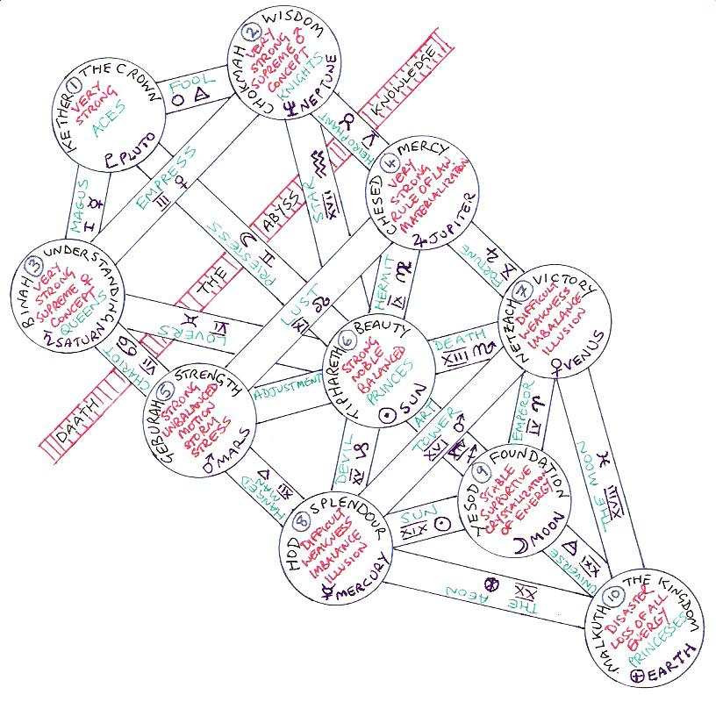Figure 2. The Tree of Life

Crowley's card titles for the Court cards are used in the following descriptions.

The **first sephira is Kether**, or the crown, the highest sephira. It represents the **absolute** and is very strong. It is ruled by Pluto and is home to the Aces, which define the suit in principle.

The **second sephira is Chokmah**, which represents **Wisdom**. It is the sphere of the zodiac and home to the All-father, the Knights and the Twos. It represents the supreme male concept and is very strong. It is ruled by Neptune.

The **third sephira is Binah**, which represents **Understanding**. It is the sphere of Saturn and home to the Great Mother, Queens and Threes. It represents the supreme female concept and is very strong. It is ruled by Saturn.

The concept of the Abyss will be described later. In simple terms the 3 spheres above the Abyss are conceptual and beyond the understanding of 'normal' intellect. The spheres below the Abyss are manifest and not only conceptual. i.e. they exist in a way which is understandable by 'normal' intellectual processes.

The **fourth sephira is Chesed**, which represents **Mercy**. It is the sphere of Jupiter. It is the highest sephira below the abyss and is therefore the highest manifestation of the universe in actuality. It is the rule of law and it is very strong. It is ruled by Jupiter and home of the Fours which define the suits in actuality.

The **fifth sephira is Geburah**, which represents **Strength**. It is the sphere of Mars and indicates motion, stress and storm. It is strong but unbalanced. Home of the Fives, it is ruled by Mars.

The **sixth sephira is Tiphareth**, which represents **Beauty**. It is the sphere of Sol. It is a direct reflection and first balanced manifestation of the Kether (Aces) and so it is strong and noble: energy in completely balanced manifestation. It is home to the Princes and Sixes and is ruled by the Sun.

The **seventh sephira is Netzach**, which represents **Victory**. It is the sphere of Venus. It is unbalanced, difficult and weak, indicating a masculine female. Illusion is present. It is home to the Sevens and is ruled by Venus.

The **eighth sephira is Hod**, which represents **Splendour**. It is the sphere of Mercury. It is unbalanced, difficult and weak, indicating an effeminate male. Illusion is present. It is home to the Eights and is ruled by Mercury. The original energy of the suit is beginning to run out this far down the Tree and planetary and zodiacal influences become more important.

The **ninth sephira is Yesod**, which represents the **Foundation**. Its is the sphere of Luna. It is the seat of the greatest crystallization of energy and is stable and supportive (though not on Yetzirah – Swords). It is home to the Nines and is ruled by the Moon.

The **tenth sephira is Malkuth**, which represents the **Kingdom**. It is the sphere of Earth. It represents the end and loss of all energy and is a disaster as the suits are about to lose their identity, though not in Assiah – Disks; the very bottom has nowhere to go except the very top. It is the material world and is home to the Princesses and Tens. It is ruled by the Earth.